database schema

The description of a database is called the database schema. This will be defined during the design phase. (OR)

A database schema is the skeleton structure that represents the logical view of the entire database. It defines how the data is organized and how the relations among them are associated.

Example :

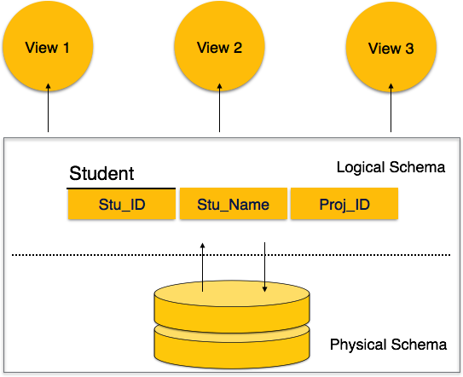

database state or snapshot or instance
The actual data in a database may change frequently. A data in a particular moment of time is called a database state or snapshot .or database instance.

The Three-Schema Architecture (OR) levels of data abstraction (or)

Three Tier Architecture of DBMS

The database approach provides some level of abstraction by hiding details of data storage that are not needed by most database users.

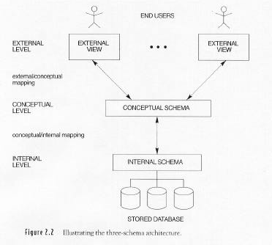

The Internal level / physical level

The internal level has an internal schema, which describes the physical storage structure of the database.

The internal schema uses a physical data model and describes the complete details of data storage and access paths for the database.

The conceptual level /logical level

The conceptual level has a conceptual schema, which describes what data are stored in database and what relationship among those data
The conceptual schema hides the details of physical storage structures. It concentrates on describing:

entities, data types, relationships, user operations, and constraints.

A high-level data model or an implementation data model can be used at this level.

The external level /view level

The external level includes a number of external schemas or user views. This is the highest level. A high-level data model or an implementation data model can be used at this level.

